Representation State Transfer (REST)

Representation State Transfer (REST) appeals to developers because it has a simpler style that makes it easier to use than SOAP. It also less verbose so that less volume is sent when communicating. The interaction is illustrated in the figure below. More on [REST](https://www.service-architecture.com/articles/web-services/representational_state_transfer_rest.html).

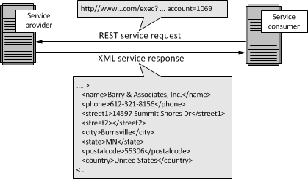

JavaScript Object Notation (JSON)

While both SOAP and REST use XML for interchange, JavaScript Object Notation (JSON) uses a subset of JavaScript. This is illustrated in the figure below. More on [JSON](https://www.service-architecture.com/articles/web-services/javascript_object_notation_json.html).

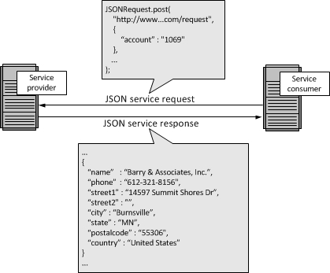

When to Use SOAP, REST, JSON or Other Options

There really is no "best" option for Web Services. Generally, you will use whatever your service provider supports. If you use multiple service providers, it is easily possible that you will be using all three Web Services specifications: SOAP, REST, and JSON.

History of the Web Services Specification

Web Services Description Language (WSDL); Universal Description and Discovery (UDDI); and SOAP formed the original Web Services specification. This section provides a history.

Web Services Description Language (WSDL)

The Web Services Description Language (WSDL) forms the basis for the original Web Services specification. The following figure illustrates the use of WSDL. At the left is a service provider. At the right is a service consumer. The steps involved in providing and consuming a service are:

1. A service provider describes its service using WSDL. This definition is published to a repository of services. The repository could use Universal Description, Discovery, and Integration (UDDI). Other forms of directories could also be used.
2. A service consumer issues one or more queries to the repository to locate a service and determine how to communicate with that service.
3. Part of the WSDL provided by the service provider is passed to the service consumer. This tells the service consumer what the requests and responses are for the service provider.
4. The service consumer uses the WSDL to send a request to the service provider.
5. The service provider provides the expected response to the s